**Laboratoire 8**

Utiliser le fichier BD_sales.bak pour restaurer la base de données.

À l’aide de cette base de données, répondez aux questions suivantes:

1. Afficher le nom du produit le plus vendu avec deux méthodes différentes et comparer les deux méthodes en termes de performance en utilisant **SHOWPLAN_ALL, STATISTICS PROFIL, etc.**
   1. TOP

SELECT TOP 5 p.product_name, SUM(oi.quantity) AS total_quantity

FROM production.products p

JOIN production.stocks s ON p.product_id = s.product_id

JOIN sales.order_items oi ON oi.product_id = p.product_id

GROUP BY p.product_name

ORDER BY SUM(oi.quantity) DESC;

* 1. TOP avec SET STATISTICS PROFILE ON;

SET STATISTICS PROFILE Off;

SET STATISTICS PROFILE ON;

GO

SELECT TOP 5 p.product_name, SUM(oi.quantity) AS total_quantity

FROM production.products p

JOIN production.stocks s ON p.product_id = s.product_id

JOIN sales.order_items oi ON oi.product_id = p.product_id

GROUP BY p.product_name

ORDER BY SUM(oi.quantity) DESC;

* 1. TOP avec SET SHOWPLAN_ALL ON;

SET SHOWPLAN_ALL Off;

SET SHOWPLAN_ALL ON;

GO

SELECT TOP 5 p.product_name, SUM(oi.quantity) AS total_quantity

FROM production.products p

JOIN production.stocks s ON p.product_id = s.product_id

JOIN sales.order_items oi ON oi.product_id = p.product_id

GROUP BY p.product_name

ORDER BY SUM(oi.quantity) DESC;

* 1. MAX

SELECT p.product_name, SUM(oi.quantity) AS total_sales

FROM production.products p

JOIN production.stocks s ON p.product_id = s.product_id

JOIN sales.order_items oi ON oi.product_id = p.product_id

GROUP BY p.product_name

HAVING SUM(oi.quantity) = (

SELECT MAX(sales)

FROM (

SELECT SUM(oi.quantity) AS sales

FROM production.products p

JOIN production.stocks s ON p.product_id = s.product_id

JOIN sales.order_items oi ON oi.product_id = p.product_id

GROUP BY p.product_name

) AS sales_by_product

);

1. MAX SET STATISTICS PROFILE ON

SET STATISTICS PROFILE Off;

SET STATISTICS PROFILE ON;

GO

SELECT p.product_name, SUM(oi.quantity) AS total_sales

FROM production.products p

JOIN production.stocks s ON p.product_id = s.product_id

JOIN sales.order_items oi ON oi.product_id = p.product_id

GROUP BY p.product_name

HAVING SUM(oi.quantity) = (

SELECT MAX(sales)

FROM (

SELECT SUM(oi.quantity) AS sales

FROM production.products p

JOIN production.stocks s ON p.product_id = s.product_id

JOIN sales.order_items oi ON oi.product_id = p.product_id

GROUP BY p.product_name

) AS sales_by_product

);

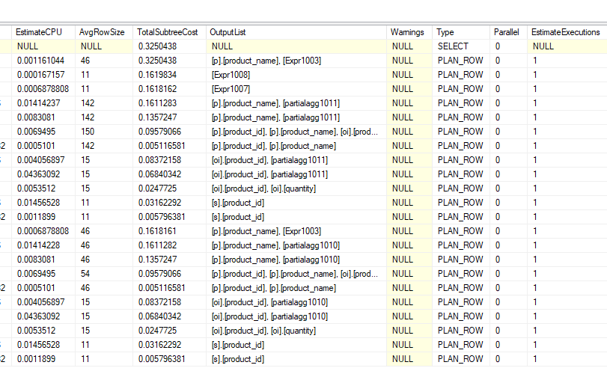

1. MAX SET SHOWPLAN_ALL ON

SET SHOWPLAN_ALL Off;

SET SHOWPLAN_ALL ON;

GO

SELECT p.product_name, SUM(oi.quantity) AS total_sales

FROM production.products p

JOIN production.stocks s ON p.product_id = s.product_id

JOIN sales.order_items oi ON oi.product_id = p.product_id

GROUP BY p.product_name

HAVING SUM(oi.quantity) = (

SELECT MAX(sales)

FROM (

SELECT SUM(oi.quantity) AS sales

FROM production.products p

JOIN production.stocks s ON p.product_id = s.product_id

JOIN sales.order_items oi ON oi.product_id = p.product_id

GROUP BY p.product_name

) AS sales_by_product

);

1. En utilisant le Case, afficher les colonnes suivantes (category_id, prix moyen, classement)

Le texte de la colonne classement généré en fonction de la valeur de **prix_moyen**

|  |  |  |
| --- | --- | --- |
| category_id | prix_moyen (prix moyen des produits) | classement |
| 1 | prix_moyen < 30 | Moins cher |
| 2 | 30 <= prix_moyen < 50 | Cher |
| 3 | prix_moyen >= 50 | Très cher |
| … |  | … |
| 7 |  | … |

-- Ceci calculera le prix moyen (AVG(list_price)) pour chaque catégorie

-- (GROUP BY category_id)

-- On utilise une instruction CASE

-- pour générer la colonne "classement" en fonction de la valeur du prix moyen.

-- Le résultat obtenu comprendra les colonnes category_id, prix moyen et classement.

SELECT category_id, AVG(list_price) AS 'prix moyen',

CASE

WHEN AVG(list_price) < 30 THEN 'Moins cher'

WHEN AVG(list_price) >= 30 AND AVG(list_price) < 50 THEN 'Cher'

ELSE 'Très cher'

END AS 'classement'

FROM production.products

GROUP BY category_id;

